**Section 1.9**

1. A pair of points is graphed. Find the distance between them. Find the midpoint of the segment that joins them.

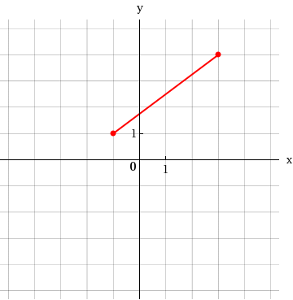

~~~~~~~~~~~~~~~~~~~~~~~~~~~~~~~~~~~~

3. Show that the triangle with vertices $A\left(0, 1\right)$, $B(-2, -1)$ and $C\left(-6, 5\right)$ is isosceles.

~~~~~~~~~~~~~~~~~~~~~~~~~~~~~~~~~

To show that the triangle is isosceles (two sides have equal lengths) we must first find the length of all three sides of the triangle.

$d\left(A, B\right)=\sqrt{{\left(x_{2}-x_{1}\right)}^{2}+{\left(y_{2}-y_{1}\right)}^{2}}$

$=\sqrt{{\left(-2-0\right)}^{2}+{\left(-1-1\right)}^{2}}$

$=\sqrt{8}$

$=\sqrt{4}∙\sqrt{2}$

$=2\sqrt{2}$

$d\left(B, C\right)=\sqrt{{\left(x_{2}-x_{1}\right)}^{2}+{\left(y_{2}-y_{1}\right)}^{2}}$

$=\sqrt{{\left(-6--2\right)}^{2}+{\left(5--1\right)}^{2}}$

$=\sqrt{52}$

$=\sqrt{4}∙\sqrt{13}$

$=2\sqrt{13}$

$d\left(A, C\right)=\sqrt{{\left(x_{2}-x_{1}\right)}^{2}+{\left(y_{2}-y_{1}\right)}^{2}}$

$=\sqrt{{\left(-6-0\right)}^{2}+{\left(5-1\right)}^{2}}$

$=\sqrt{52}$

$=\sqrt{4}∙\sqrt{13}$

$=2\sqrt{13}$

Since BC and AC have the same length, then the triangle is isosceles.

2. A pair of points is graphed. Find the distance between them. Find the midpoint of the segment that joins them.

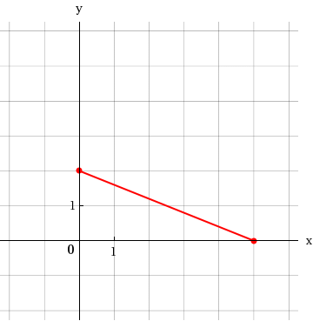

~~~~~~~~~~~~~~~~~~~~~~~~~~~~~~~~~~~~

4. Which of the points $A\left(9, 10\right)$ or $B(-1, 10)$ is closer to the origin?

~~~~~~~~~~~~~~~~~~~~~~~~~~~~~~~~

5. Find the center and radius of the circle. Then sketch its graph.

a. $x^{2}+y^{2}=4$

b. ${(x+4)}^{2}+{(y-5)}^{2}=25$

~~~~~~~~~~~~~~~~~~~~~~~~~~~~~~~~

a. Center = $(0, 0)$

Radius $=\sqrt{4}=2$

Graph:

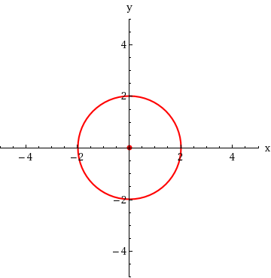

b. Center = $(-4, 5)$

Radius

Graph:

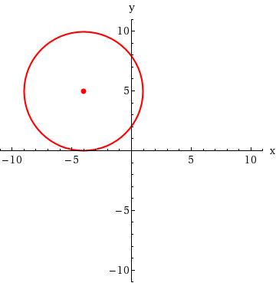

7. Find an equation of the circle that satisfies the given conditions.

a. Center $(-3, 7)$; Radius 4

b. Center $(2, -6)$; Passes through $(5, 4)$

~~~~~~~~~~~~~~~~~~~~~~~~~~~~~~~~~~~~~

a. ${(x-h)}^{2}+{(y-k)}^{2}=r^{2}$

${(x--3)}^{2}+{(y-7)}^{2}=4^{2}$

${(x+3)}^{2}+{(y-7)}^{2}=16$

b. Radius:

6. Find the center and radius of the circle. Then sketch its graph.

a.

b.

~~~~~~~~~~~~~~~~~~~~~~~~~~~~~~~~

8. Find an equation of the circle that satisfies the given conditions.

a. Center $(2, -1)$; Radius 6

b. Endpoints of a diameter are P and Q

~~~~~~~~~~~~~~~~~~~~~~~~~~~~~~~~~~~~~

10. Show that the equation represents a circle by rewriting it in standard form. Find the center and radius of the circle.

~~~~~~~~~~~~~~~~~~~~~~~~~~~~~~~~

9. Show that the equation represents a circle by rewriting it in standard form. Find the center and radius of the circle.

a. $x^{2}+y^{2}+10y+14=0$

b. ${4x}^{2}+{4y}^{2}-5x=0$

~~~~~~~~~~~~~~~~~~~~~~~~~~~~~~~~

a. $x^{2}+y^{2}+10y+14=0$

$x^{2} +y^{2}+10y =-14$

${(x-0)}^{2}+y^{2}+10y+25=-14+25$

${(x-0)}^{2}+(y+5)(y+5)=11$

${(x-0)}^{2}+{(y+5)}^{2}=11$

Center = $(0, -5)$

Radius = $\sqrt{11}$

b. ${4x}^{2}+{4y}^{2}-5x=0$

$x^{2}+y^{2}-\frac{5}{4}x=0$

$x^{2}-\frac{5}{4}x +y^{2}=0$

$x^{2}-\frac{5}{4}x+\frac{25}{64} +y^{2}=0+\frac{25}{64}$

$x^{2}-\frac{5}{4}x+\frac{25}{64}+y^{2}=0+\frac{25}{64}$

$\left(x-\frac{5}{8}\right)\left(x-\frac{5}{8}\right)+{(y-0)}^{2}=\frac{25}{64}$

${\left(x-\frac{5}{8}\right)}^{2}+{(y-0)}^{2}=\frac{25}{64}$

Center = $\left(\frac{5}{8}, 0\right)$

Radius = $\frac{5}{8}$